Library Management System

Course: BTECH CSE

Submitted By: Mehak Negi

Sap id: 590026050

Submitted To: Mr. Prashant Trivedi

University: University of Petroleum and Energy Studies

Abstract

The Library Management System is a simple and userfriendly software developed in the C programming language to help manage day-to-day activities of a library. Instead of using paper registers or notebooks, this system stores all information digitally using file handling.

The main purpose of this project is to make library operations faster, easier, and more accurate. The system provides two types of users: Admin and User. Admins can create profiles, log in, add new books to the collection, update existing book details, delete books, and view all users and their comments. Users can create their profile, log in, search for books, view all available books, and leave comments after reading a book.

All information-such as user details, admin details, book records, and comments-is stored permanently in files, so nothing is lost even after the program is closed. The project uses C structures, functions, loops, and file handling to create a modular and efficient system.

Overall, this project demonstrates how a simple consolebased program can replace manual work and improve the management of a library. It reduces human error, saves time, and provides a clear example of how programming can solve real-life problems.

Problem Definition

Libraries that use manual registers face difficulty in managing large numbers of books and users. Searching for a book in paper records takes too much time.

High chances of human errors such as wrong entry, missing data, or duplicate information.

Updating book details (edit/delete) becomes slow and complicated when done manually.

Users cannot easily check whether a book is available without asking the librarian.

No proper system to store and track user feedback or comments.

Manual methods make the library less efficient and more time-consuming.

There is no quick way to validate user login or store passwords securely in a notebook.

As the number of books grows, maintaining accurate records becomes difficult.

Libraries need a simple digital system to store, search, update, and manage information automatically.

Algorithm

1. Start the program and show the main menu with options for Admin, User, or Exit.

2. If the Admin chooses their menu, they can create a profile or log in.

3. Once the Admin logs in, they can manage the library by adding books, editing them, deleting them, viewing all users, or checking comments.

4. After finishing any task, the Admin is taken back to the Admin menu.

5. If the User chooses their menu, they can create a profile or log in.

6. After a User logs in, they can see their profile, search for books, view all books, or leave comments on books they have read, return and borrow books.

7. After completing any action, the User returns to the User menu. 8. If the user selects Exit from the main menu, the program closes.

9. End of the program.

Flowchart

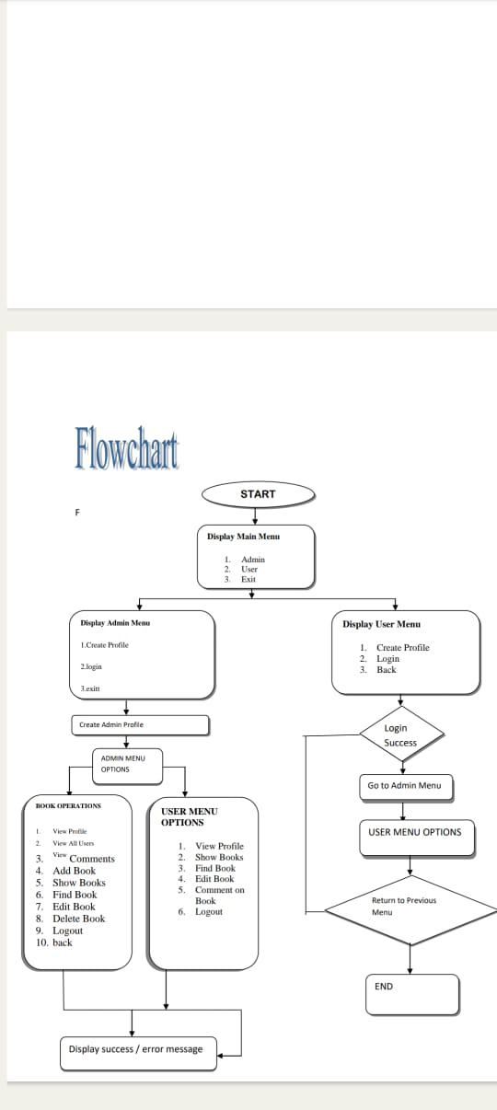

Testing & Results

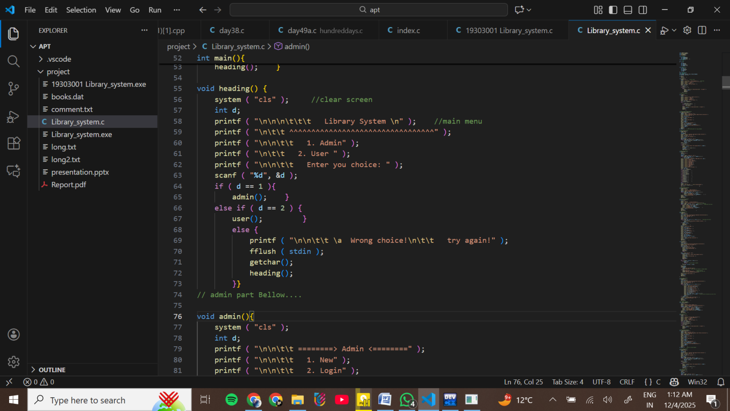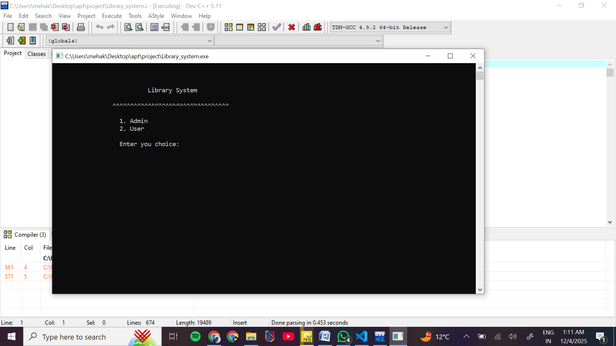

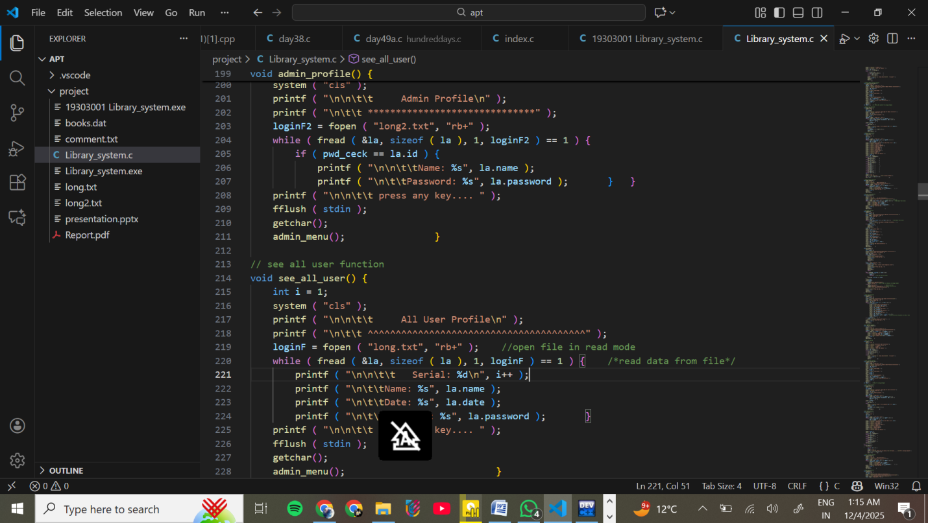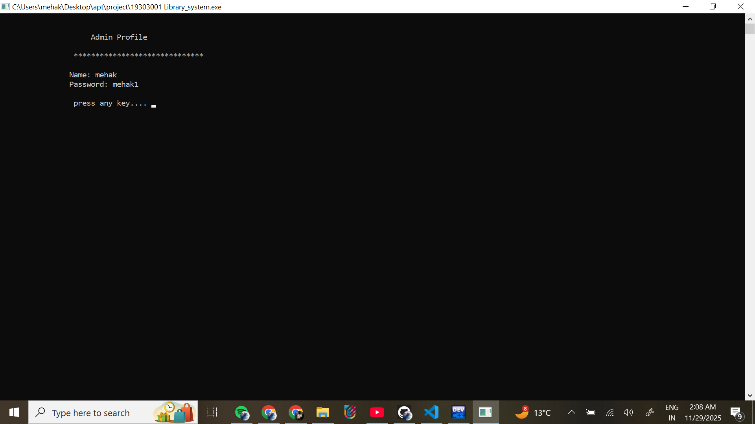

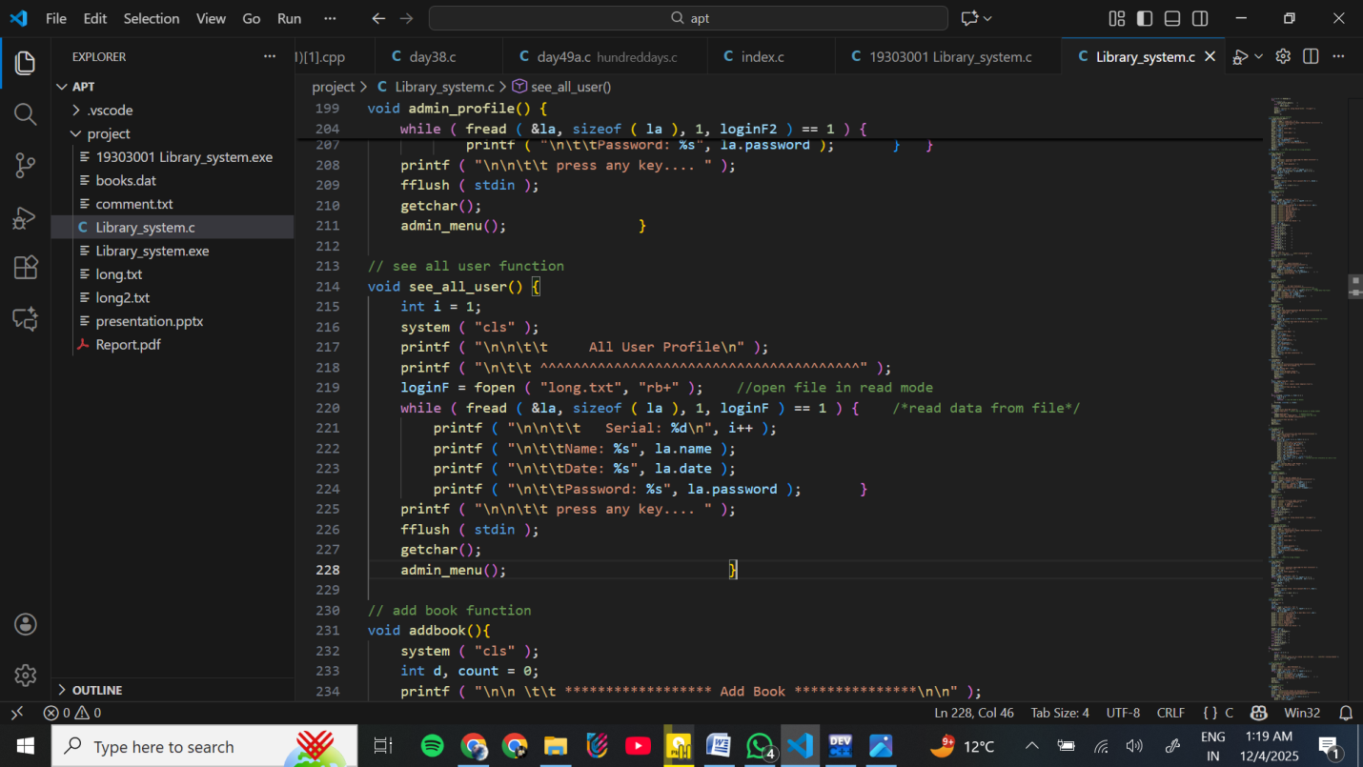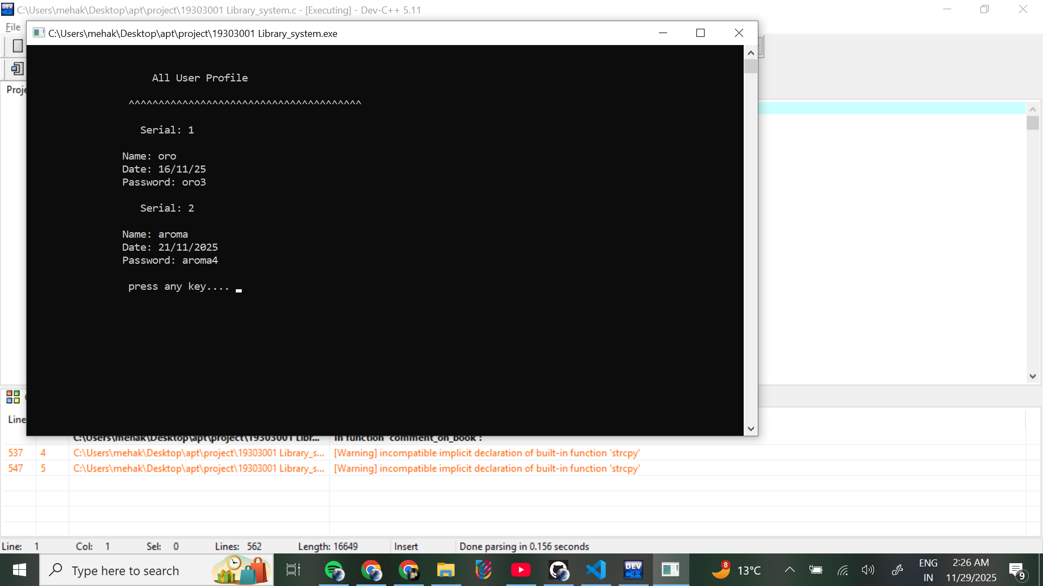

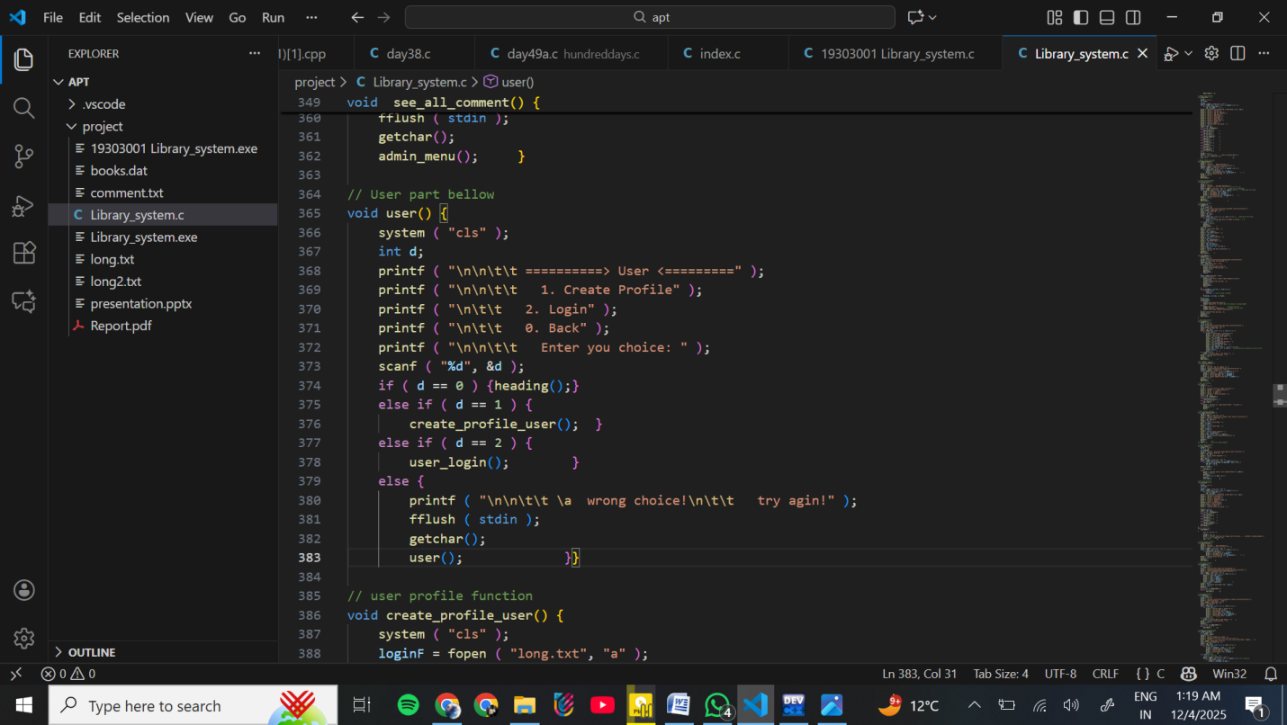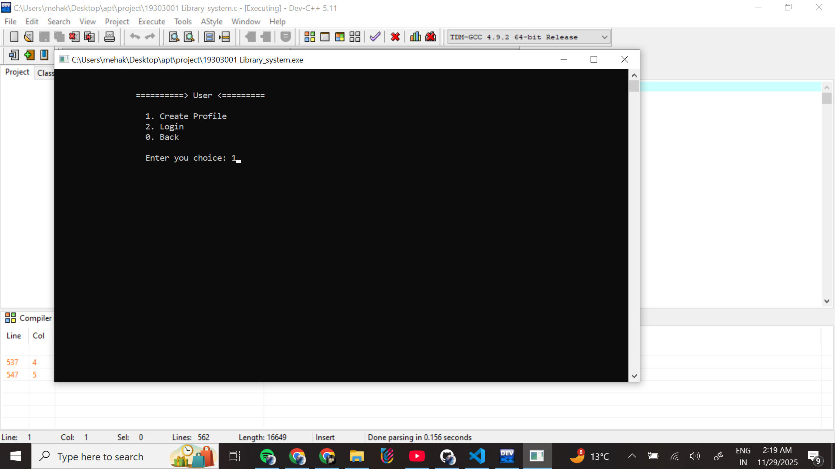

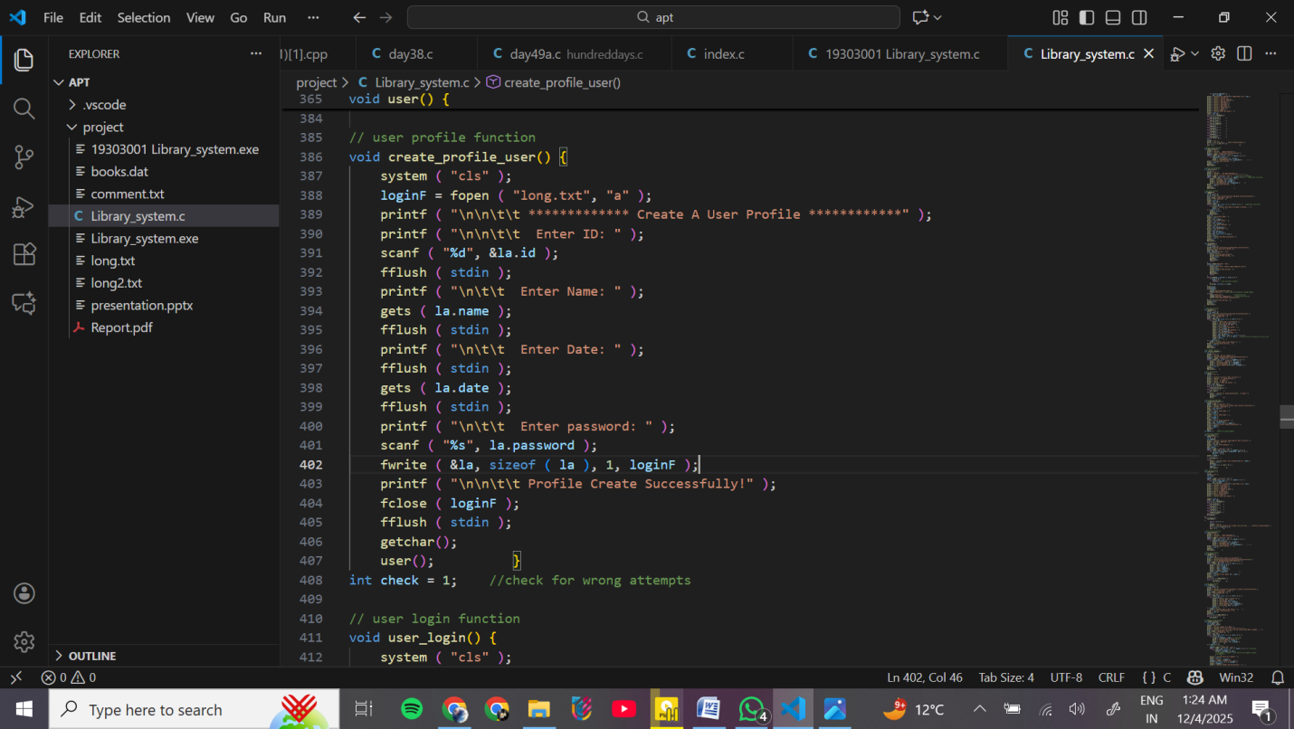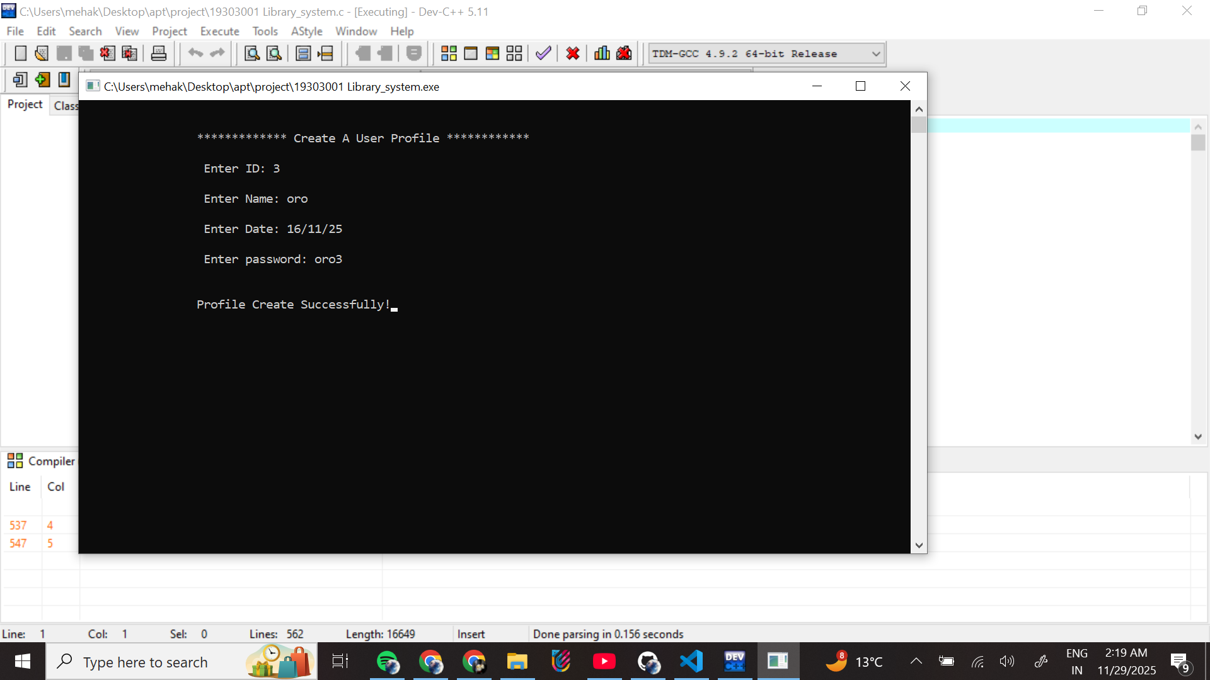

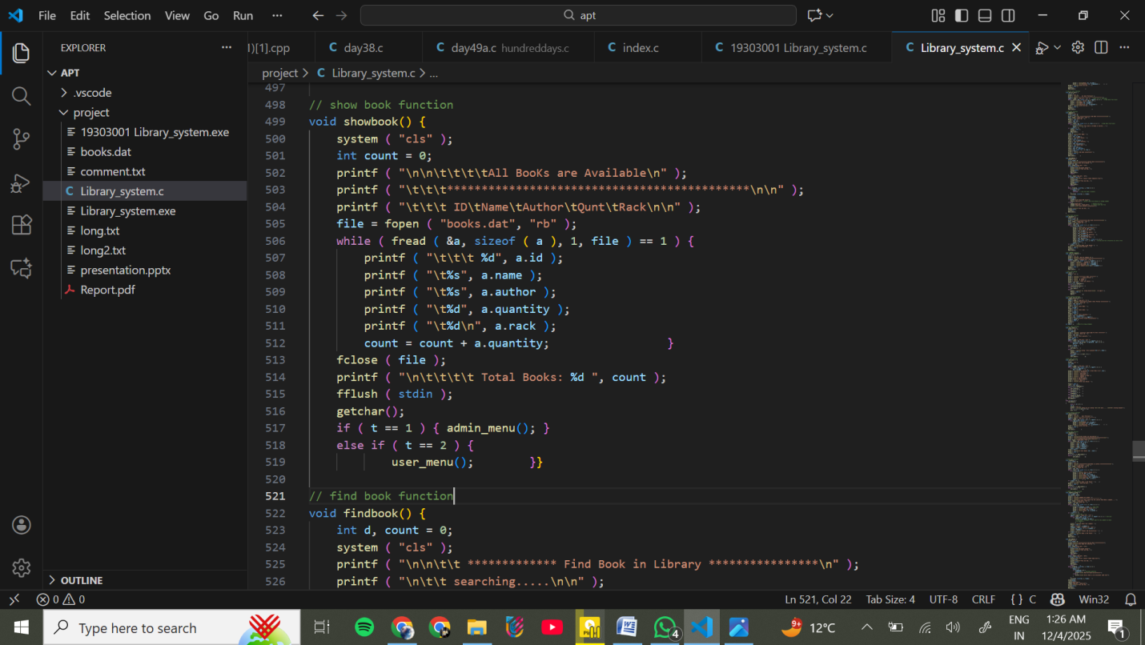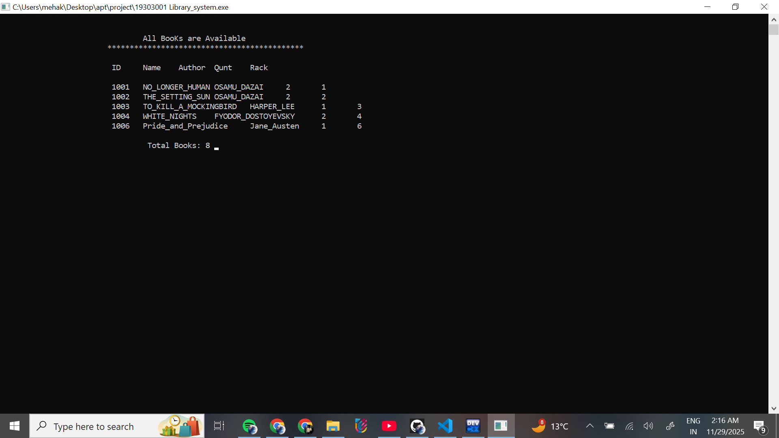

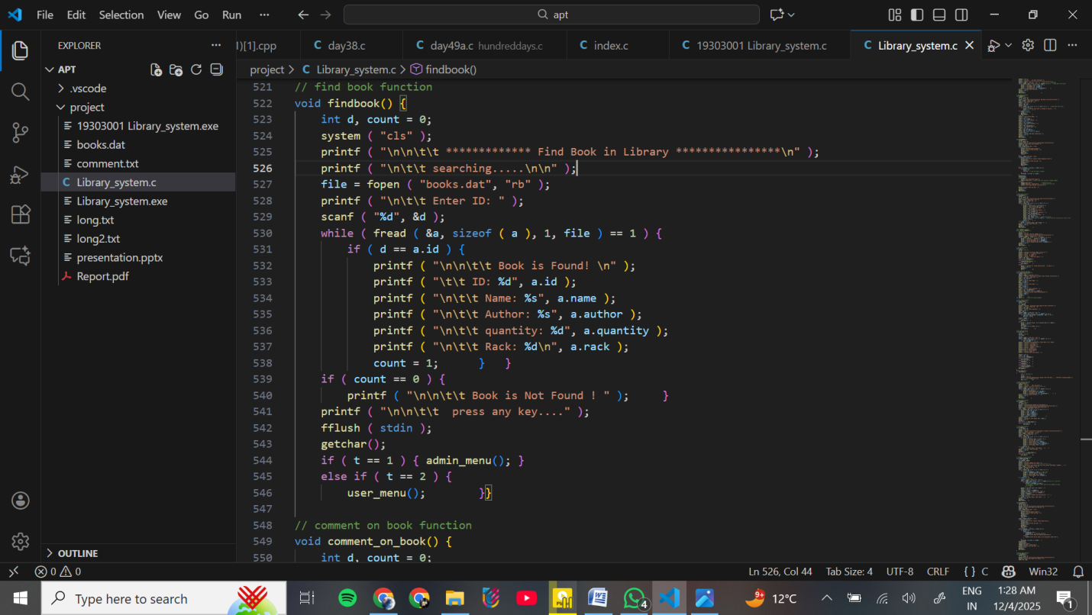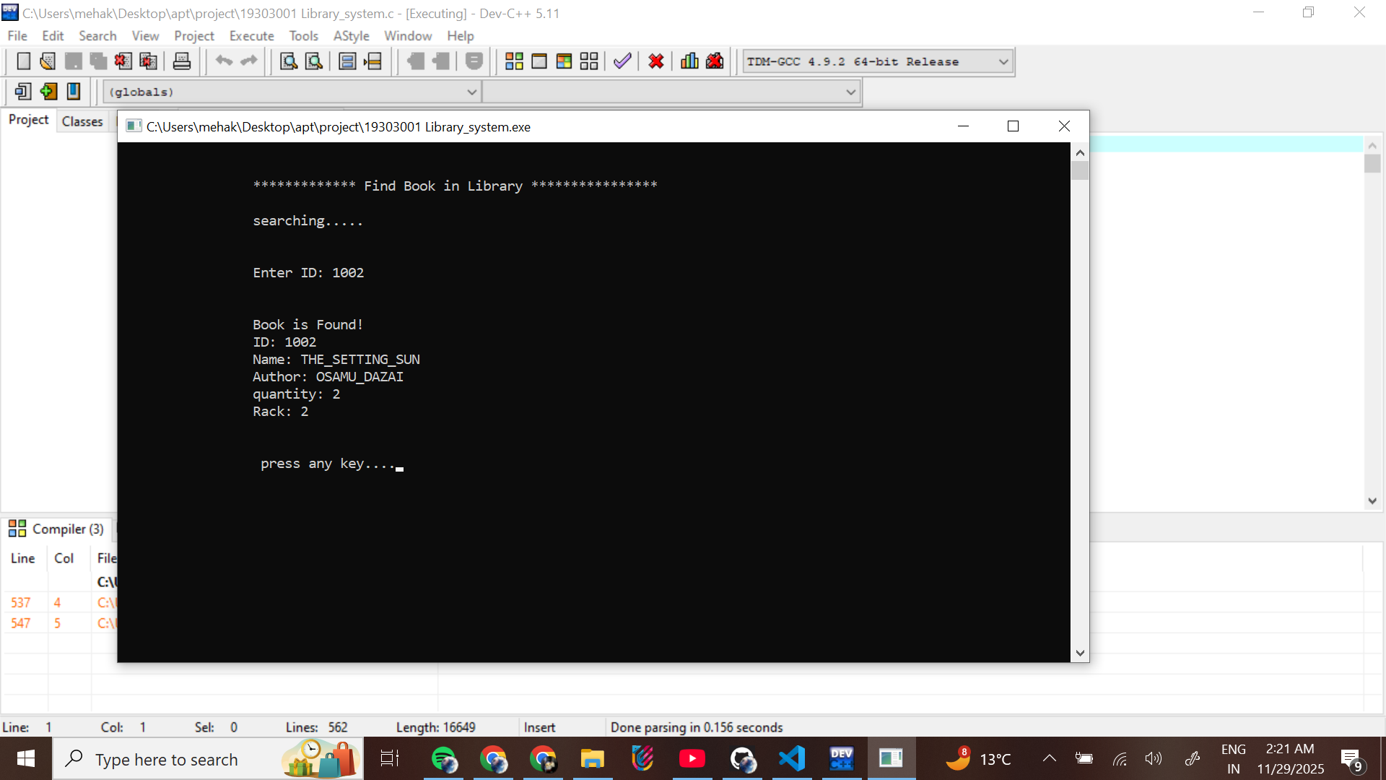

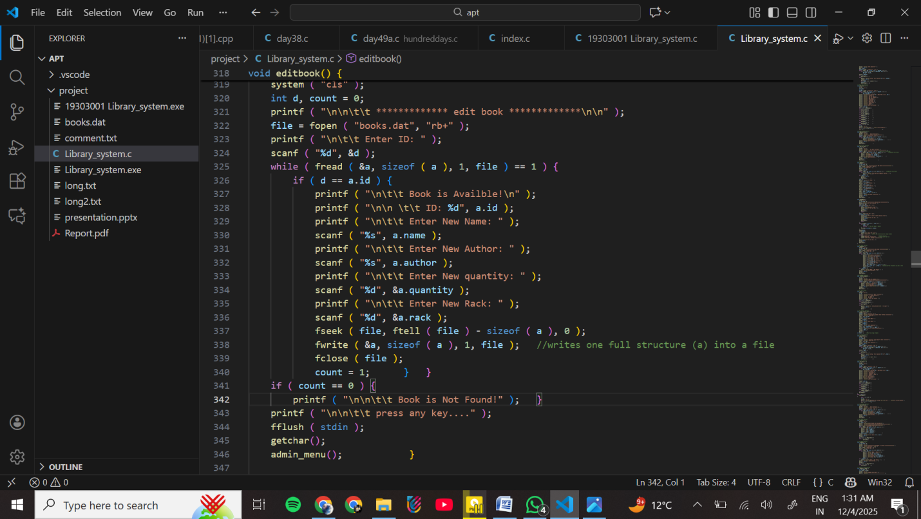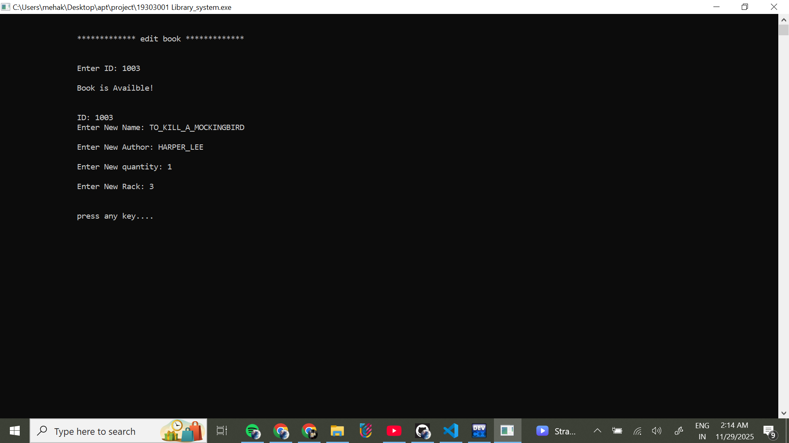

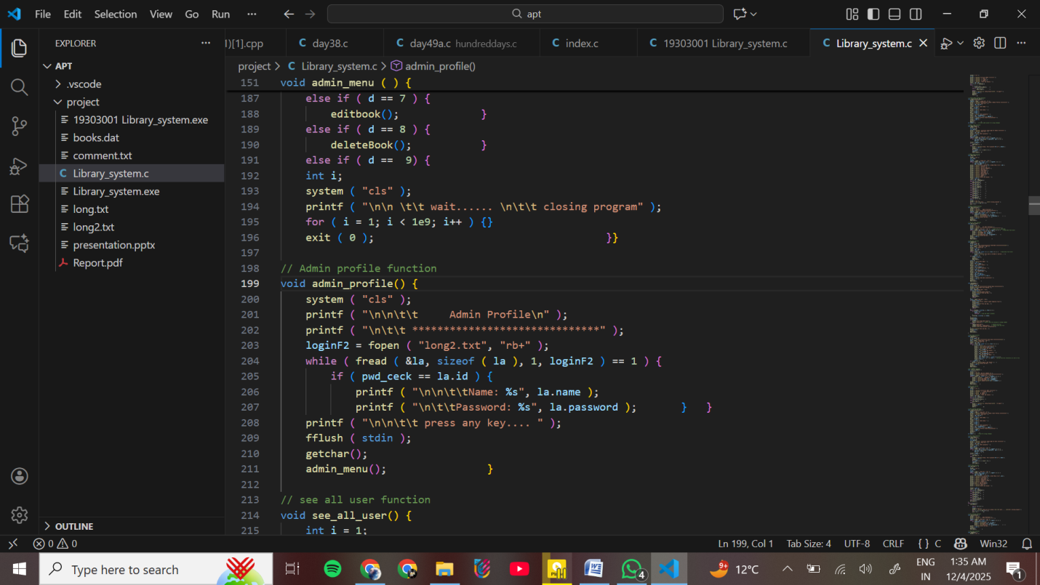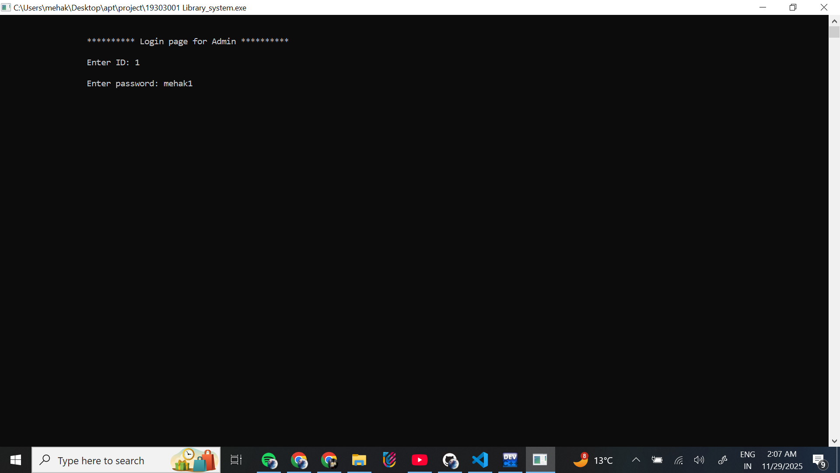

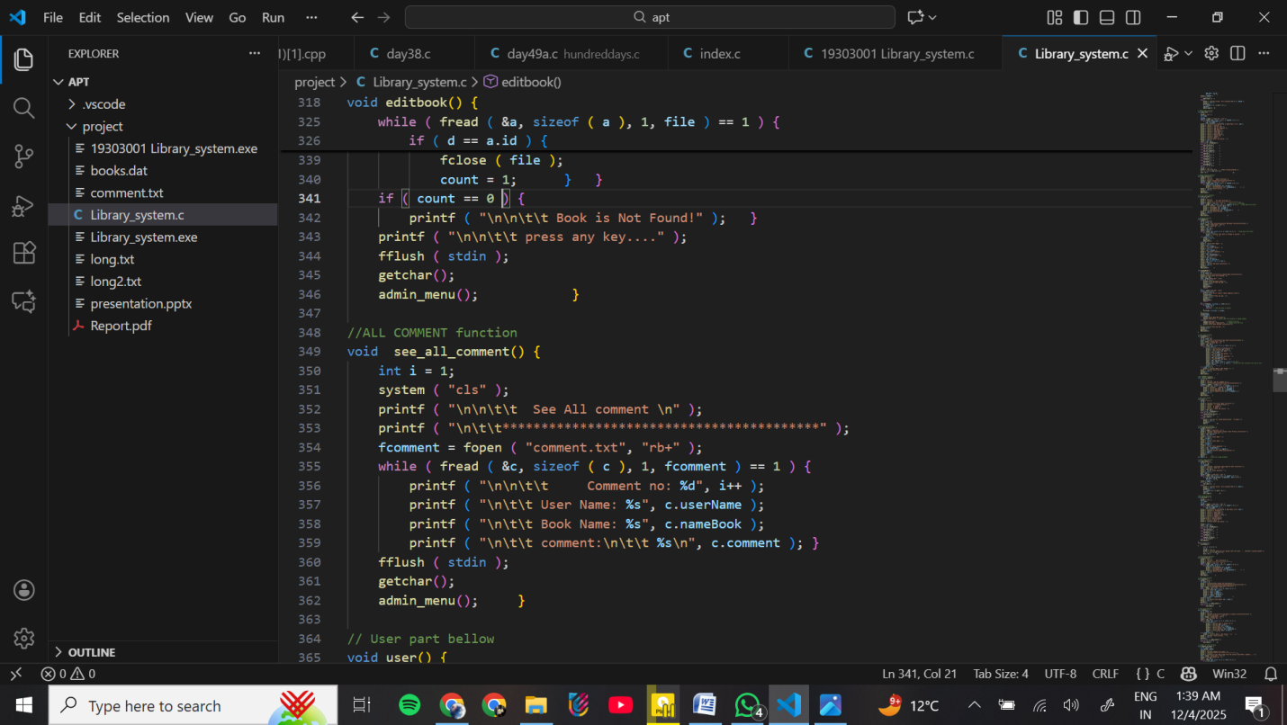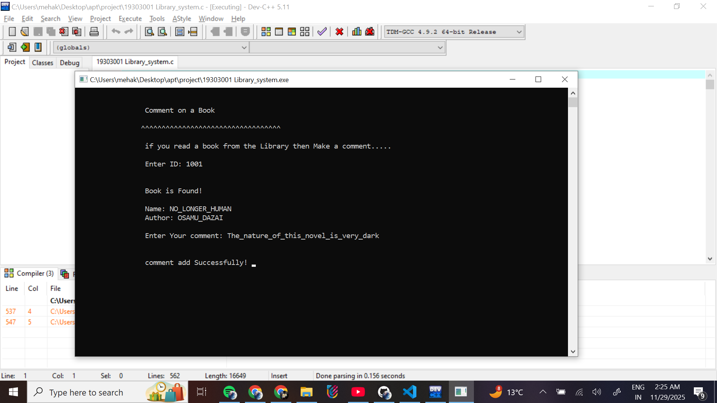

Conclusion & Future Work

Conclusion

The Library Management System successfully demonstrates how a simple C program can automate common tasks in a library. By using file handling, the system stores book records, user profiles, admin data, and comments in an organized way without relying on manual registers. The project reduces human errors, speeds up searching, and makes the process of adding or updating books more efficient. It also ensures that users have access to important features such as viewing books, checking details quickly, and sharing their feedback. This project clearly shows the importance of computerization in daily operations and highlights how even a basic console application can improve accuracy, save time, and make the library easier to manage. Overall, the system meets its goals of providing a simple, reliable, and easy-to-use digital solution for library management.

Future Work

Although the current system works well as a basic library manager, there are several improvements that can make it more powerful and user-friendly in the future:

1. Issue and Return System Add a complete borrowing and returning module where users can issue books, check due dates, and track borrowed books.

2. Fine Calculation Introduce automatic fine calculation for overdue books to make the system more realistic and useful.

3. Database Integration Instead of using files, integrate a database like MySQL or SQLite for faster, safer, and more scalable data management.

4. Online/Cloud-Based System Convert the system into a web or cloud-based application so users can check books from anywhere.

5. Search Filters Provide advanced search options like search by author, category, year, or keywords. 6.Admin Dashboard Add statistics like number of users, total books, mostread books, and user activity reports.

7. Multi-user Access Make the system capable of handling multiple users at the same time.

References

Online C Documentation (<https://www.w3schools.com> / <https://www.geeksforgeeks.org/>)

Course Material Provided by teacher